TECHNO MACHINE TOOLS
Survey no:126/A/1, DOOR NO: 4-132-9/A/2, Gandimaisamma X Road,
Medchal Malkajgeri,Hyderabad-500043.Telangana, India.

(Machine tool manufacturers)

T.SIVARAMAKRISHNA
ME., MBA.
--------------------------------------------------------------------------------------------------------------------------------------
TMT/MARYALA KAUSTAV/S073/2025 01.03.2025

To,
MARYALA KAUSTAV

Vishal Steal, Vijayawada, Andhra Pradesh, India
Mobile: +(91)-7680019709

Dear sir,

Sub: - SUPPLY OF 55 MM DECK PROFILE ROLL FORMING MACHINE

Thank you very much for your enquiry regarding your requirement of roll forming machine mainly for Deck Sections. We are glad to inform you that we would be in a position to supply you the required equipment. Given below are the required specifications and description of the machine and our terms and conditions.

Prices

The cost of Roll forming machine with Deck Profile tooling along with De Coiler, Entry guide, Main Roll Forming Machine, Side Guides, Drive System, Cutting Unit and Cutting Die Sets for Rs 37,60,000/- ( Rupees Thirty Seven Lakhs Sixty Thousand Only)

LIST OT EQUIPMENT

- HYDRAULIC DE-COILER, 10 MT CAPACITY
- ROLL FORMING MACHINE WITH 28 PASSES
- EN 31 ROOFING PROFILE ROLLERS DIE SET
- 30 HP DRIVE WITH GEAR BOXE
- COMPLETE ELECTRICALS ALONG WITH AUTOMATION – PLC
- CUTOFF ALONG WITH CUTTING TOOL

TECHNICAL SPECIFICATION:

GENERAL DATA

Productivity : ROLL FORMING CUT TO SIZE PROFILE

Manpower required : ONE OPERATOR TWO ASST. REQUIRED

Total Power Required : 47.5 HP

Set up time : COIL LOADING 2-3 MIN, SHEET FEEDING 3-4 MIN

Production capacity : 8000 KG PER SHIFT 8 HOURS

Working hours per day : 24 HOURS

Line direction : LEFT TO RIGHT

Overall floor space required : 13 METERS (L) 2 METERS (W) 1.2 METERS (H)

Approx weight : 9000 KG

Line speed : 3-15 MPM

Model No : TM/RF/111

Model Type : CRFM

MATERIAL SPECIFICATIONS

Type of material to be processed : CR/GI/AL

uts : 32-42 KG/MM2
% Elongation : 18-25
Shear strength : 40-45 KG/MM2

Maximum width can be processed : 1300 MM

Minimum width can be processed : 1020 MM

Maximum thickness can be processed : 1.6 MM

Mnimum thickness can be processed : 0.8 MM

ENTRY COIL SPECIFICATIONS

Maximum weight of coil : 10 TON

Maximum od of coil at entry : 1600 MM

Minimum od of coil at entry : 600 MM

DE COILER SPECIFICATIONS

Model : SINGLE ARM

Load - capacity : 10000 KG MAX.

width : 1300MM

Mandrel movement : DIA 450 MM - 550 MM

Mandrel Height from ground : 1100 MM

Mandrel expansion : MANUAL

Construction : M. S. FABRICATED.

Mandrel rotation : WITH 10 HP GEARED MOTOR

Power pack : 5hp

Motors

Main drive : 30 hp
De coiler power pack: 5 hp
De coiler drive: 7.5 hp
Cutting unit power pack: 5 hp


MILL SPECIFICATIONS

Roll shaft diameter : DIA 70 MM

The vertical distance between shafts : 330 MM

The horizontal distance between shafts : 550 MM

Number of forming stations : 28 NOS

Drive (AC) : 30 HP

Delivery shear : 5 HP {power pack)

Speed of the machine : 0-15 meters/max

Shaft material : EN9

Rollers Material : EN31

Hydraulic tank capacity : 300 liters

Description of the equipment

Roll Forming Machine

Main Base

The main base is MS fabricated structure and adequately ribbed to minimize the distortion. It is accurately machined on top and bottom surfaces the threaded holes are made on the bed for positioning the stands.

Entry Guide

The entry side of the machine will be equipped with guide table and the guide bar which will be responsible for centering the leading ends of the strip into the first pass.

Mill stands

The stands are mounted on the bed of the machine the line alignment can be easily done due to threaded holes arranged on the bed of the machine. Each forming head consists of a fixed housing and sliding type out board housing. The mill stands will be arranged to locate shafts mounted on anti-friction bearings. For the top shafts the bearings are housed in the cartridge type bearing blocks. The bottom shaft bearings are located in the bored machined in the housings. The bottom arbors are fixed in position whereas the top arbors along with cartridge blocks could be raised or lowered in vertical guides machined in housings.

Roll shafts

The roll shafts will be manufactured from quality steel and will be keyed to locate tooling.

Drive

The drive to the roll former will be by means of a gear box system. The main drive will be provided by means of 20 HP motor. The speed of the roll former is variable.

Cutoff unit

The cutoff unit with hydraulic press along with cutting die set will be placed in the machine delivery side. The power pack motor is 7.5 HP

Die rolls : EN31 grade

GENERAL TERMS & CONDITIONS:

- Price quoted per unit ex-work. Hyderabad.
- Following charges are additional to your account.
- Freight Charge : As actual to be borne by you.
- Excise : Extra As Applicable
- Sales Tax : Extra as applicable
- Packing charge : As actual to be borne by you.
- Insurance : As actual to be borne by you.
- Payment : 75% advance along with order balance before delivery but after inspection at our works.
- Delivery : with 75% advance 2 months / With 50% advance 3 months / With 30% - 4 months from date of advance received
- Validity : One month from the date of submission.
- Inspection : Inspection at our works prior to dispatch.
- Warranty : The machine is warranted for a period of 12 months from the date of dispatch against any manufacturing defects/ faulty material or bad workmanship of any part or component but not against any kind of abnormal or improper use of machine. Defective part or component will be replaced or repaired free of cost. Electrical components are outside the scope of this warranty.
- Commissioning : Erection & commissioning done by you, but required technical support & guidance provide by us at additional cost.

NOTE:
- Oil is not in scope of our supply.

- Raw material for trial is to be arranged by you at your cost.

We are sure you will find our offer in line with your requirements. Should you require any further clarification please contact me on mobile no.9246221106. email: md@technomachinetools.in

Thanking you and assuring you of our best services at all times.
Yours faithfully,

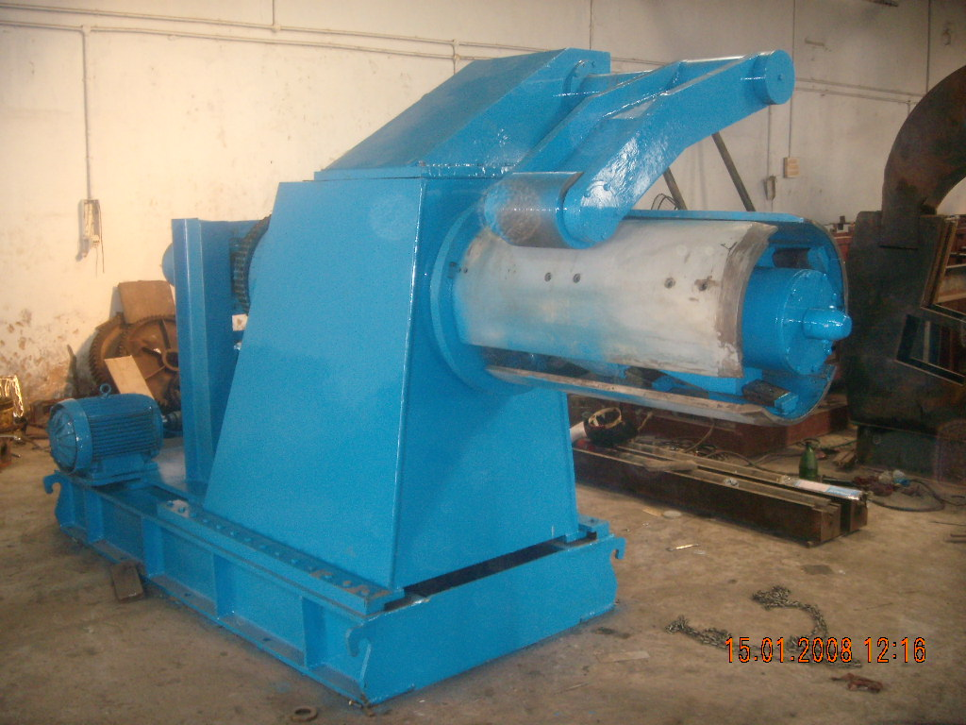

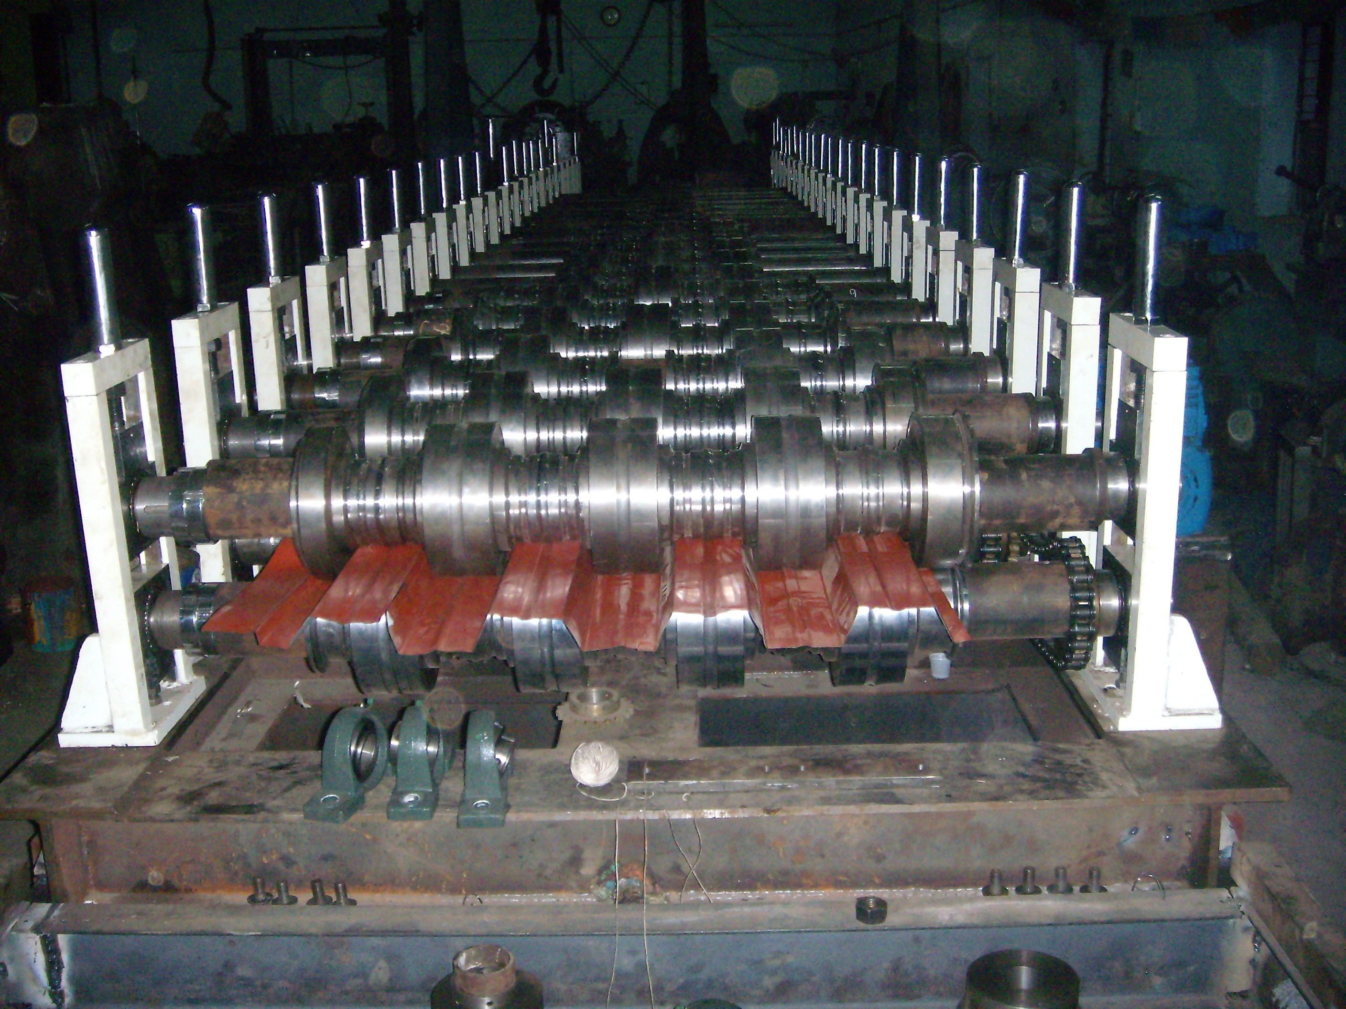
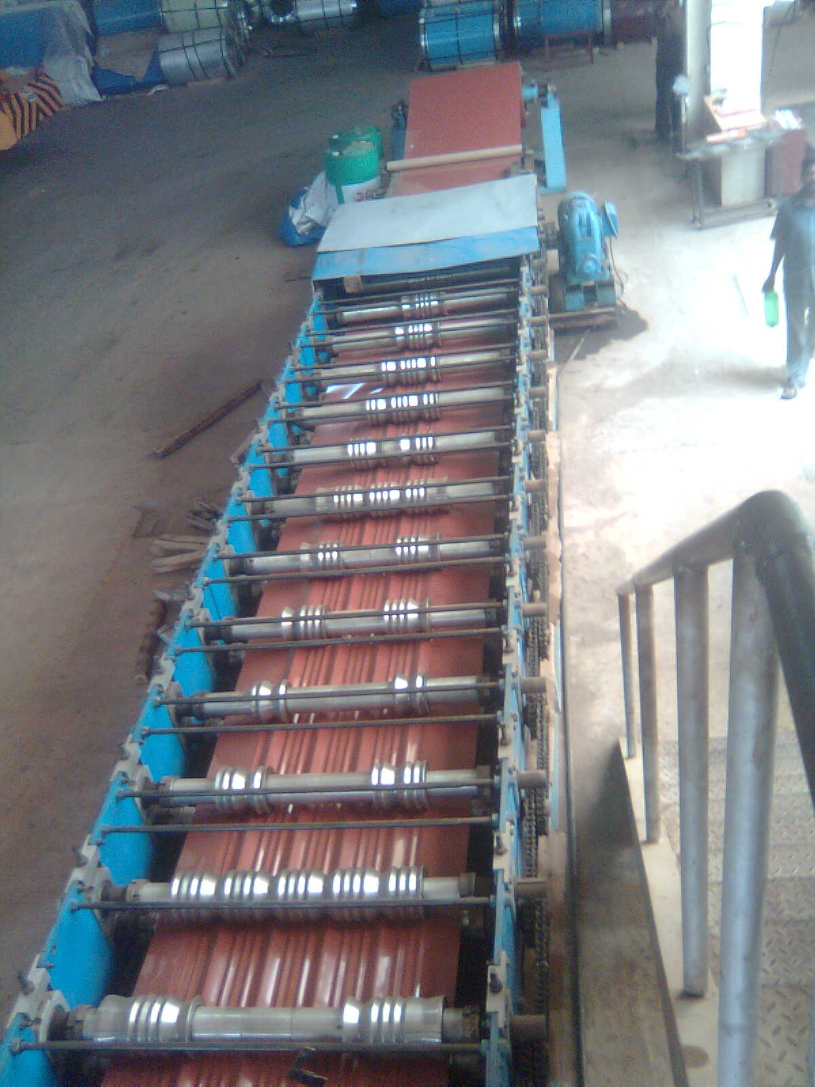

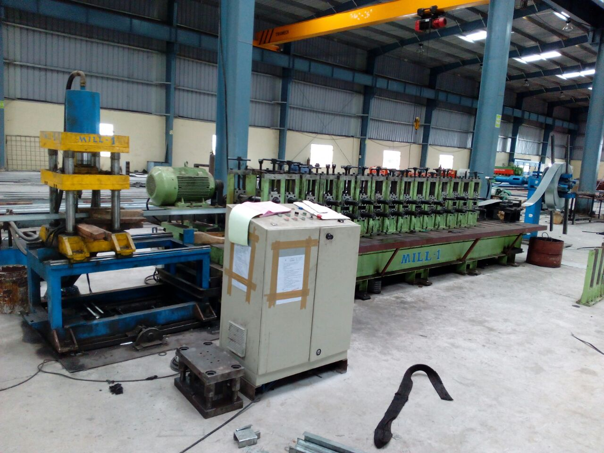

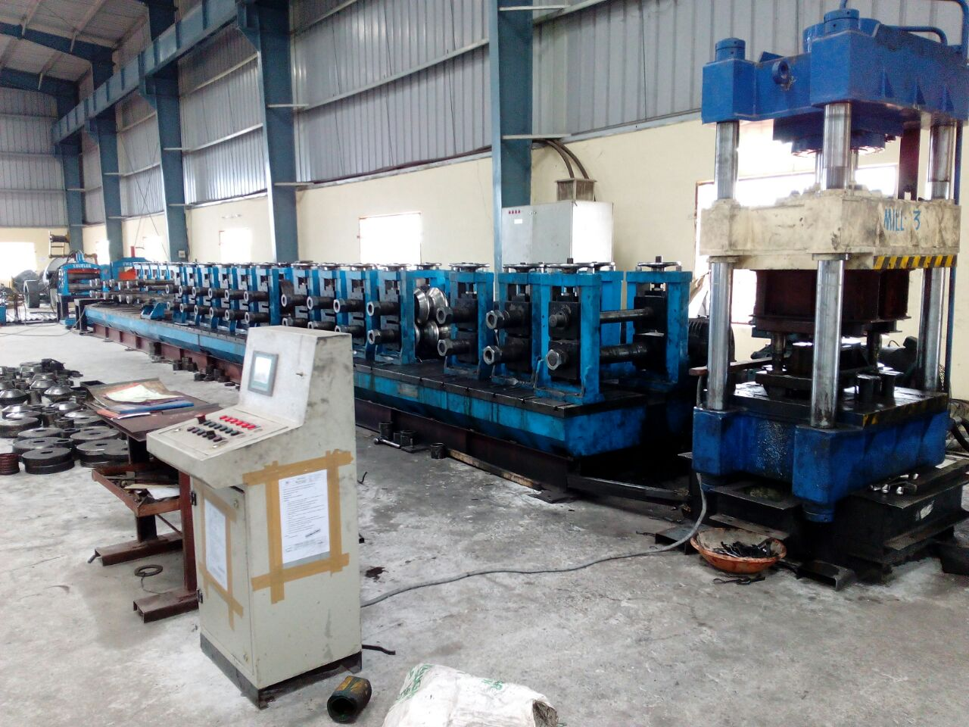

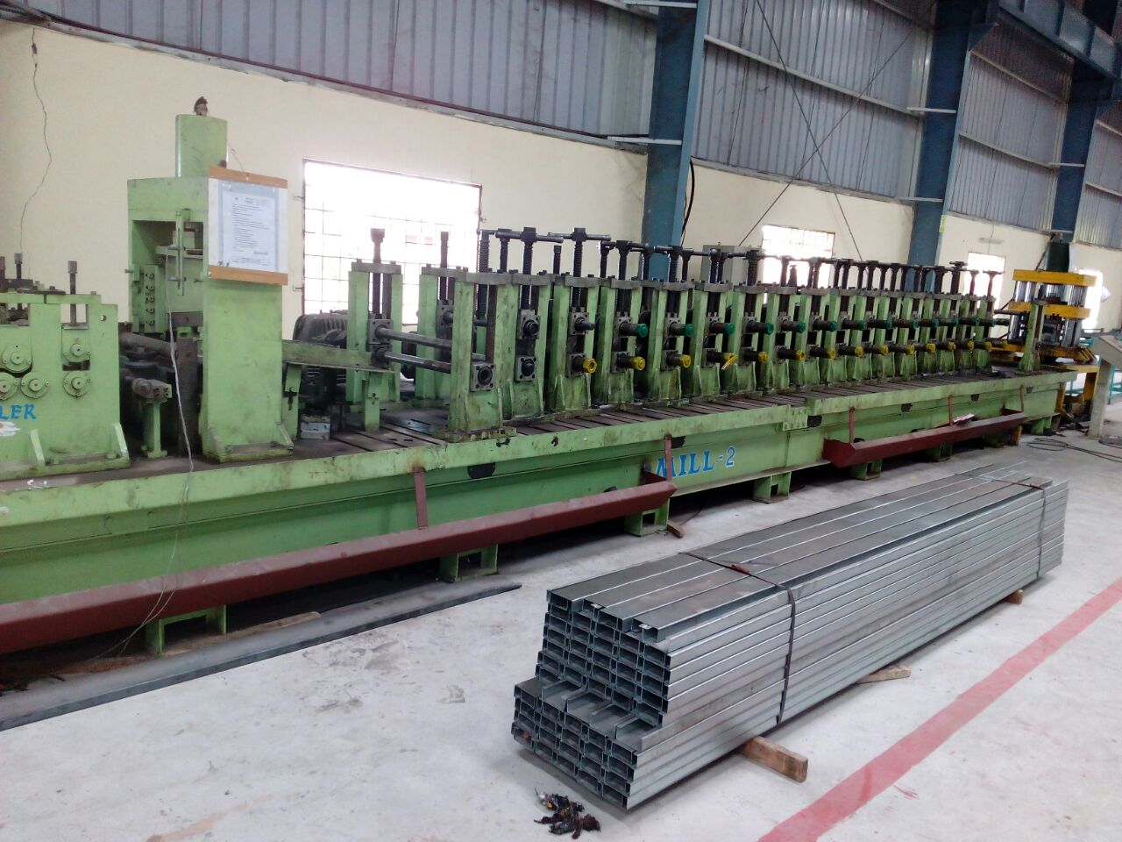
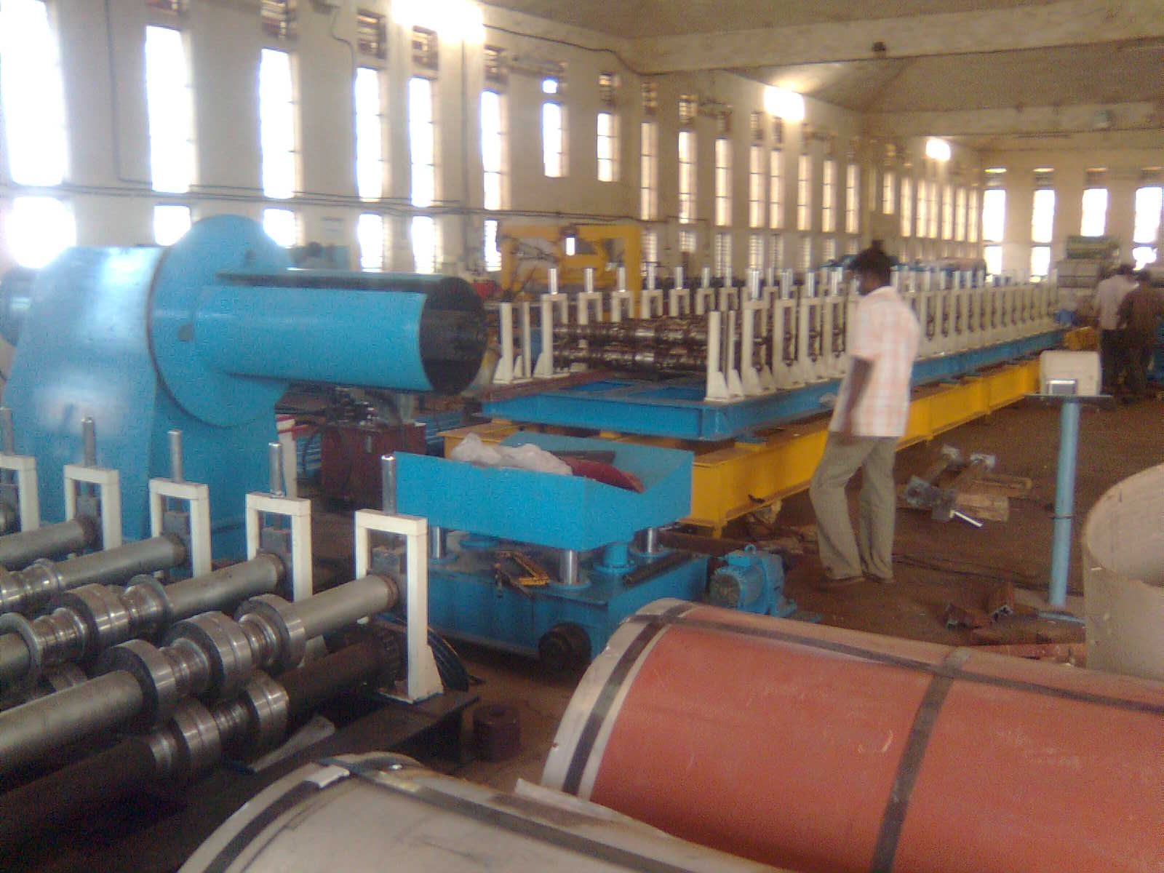

For Techno Machine Tools

(T.SIVARAMAKRISHNA)

